**Strings are like arrays in python**

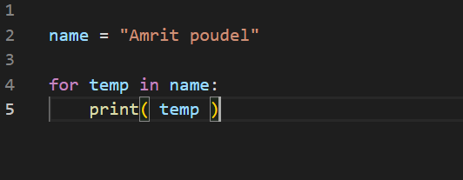

Use for…in… to loop through string

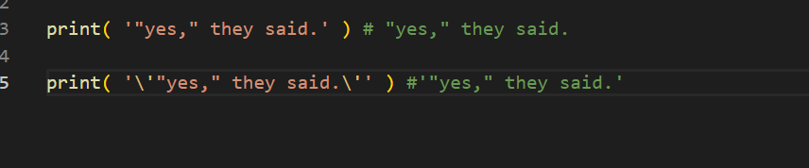

Remember these small things

\ can be used to escape single or double quotes

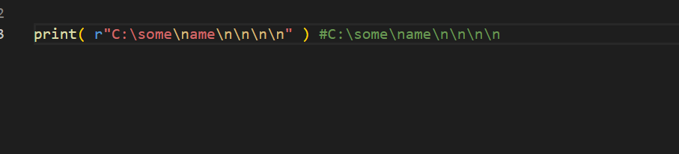

Writing r in beginning means the whole string becomes raw string and it prints all as it is, otherwise \n would become new line

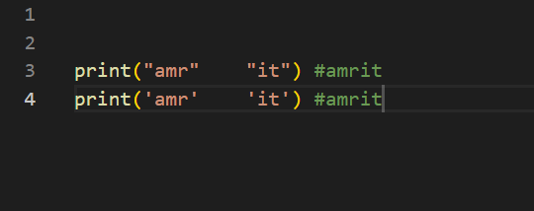

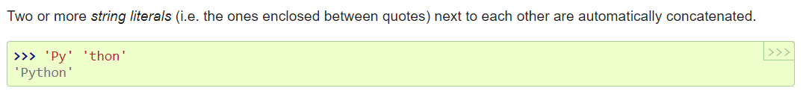

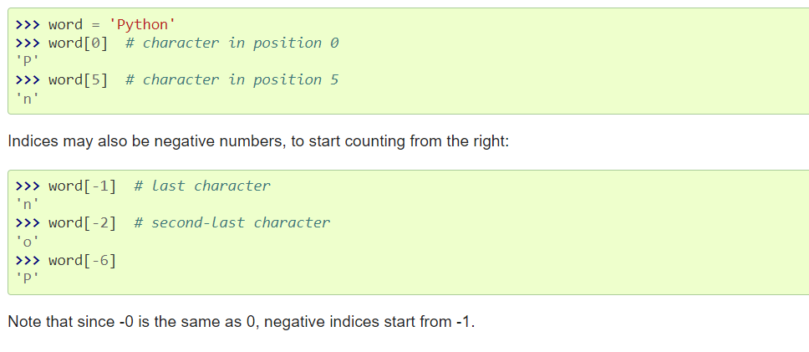

Python string is just array of characters, but there is no char data type

Python strings are **immutable** because the characters can’t be changed once a string is defined

**Slicing the string in python**

We can return a sub string from original string

Actually there is no such slice() method directly in python but we can do slicing

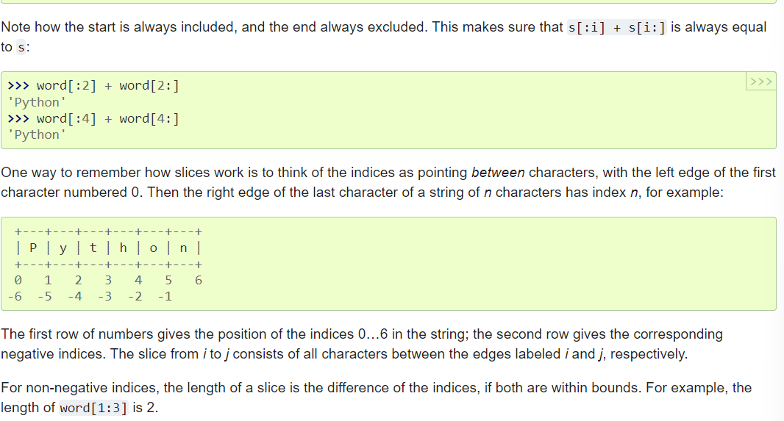

**Len() method** to find length of string

**In and not in** are really helpful

They are used to check if certain character or certain phrase present in string or not

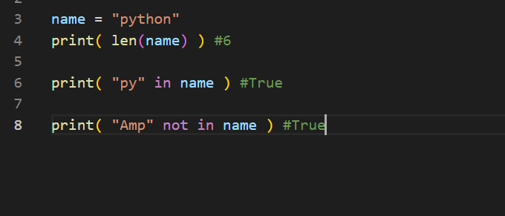

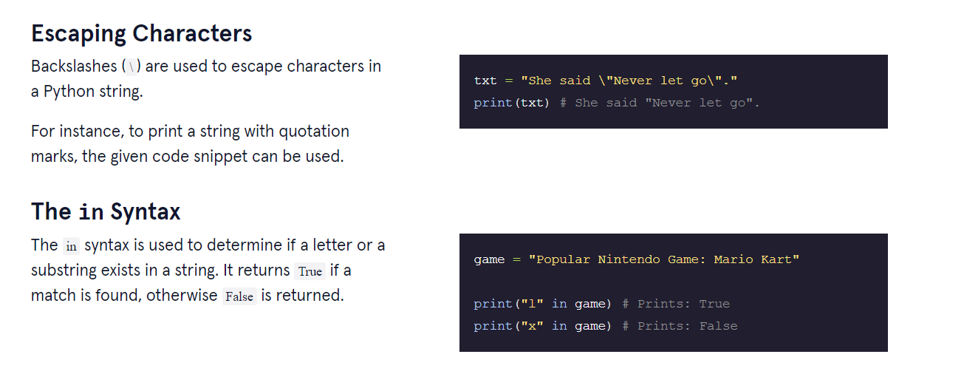

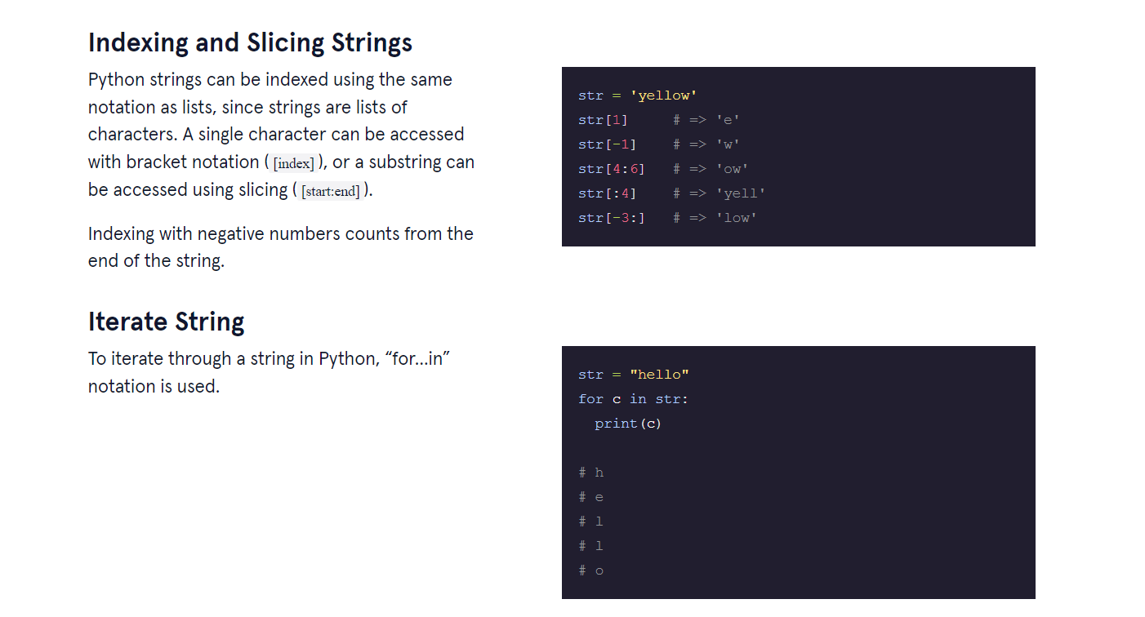

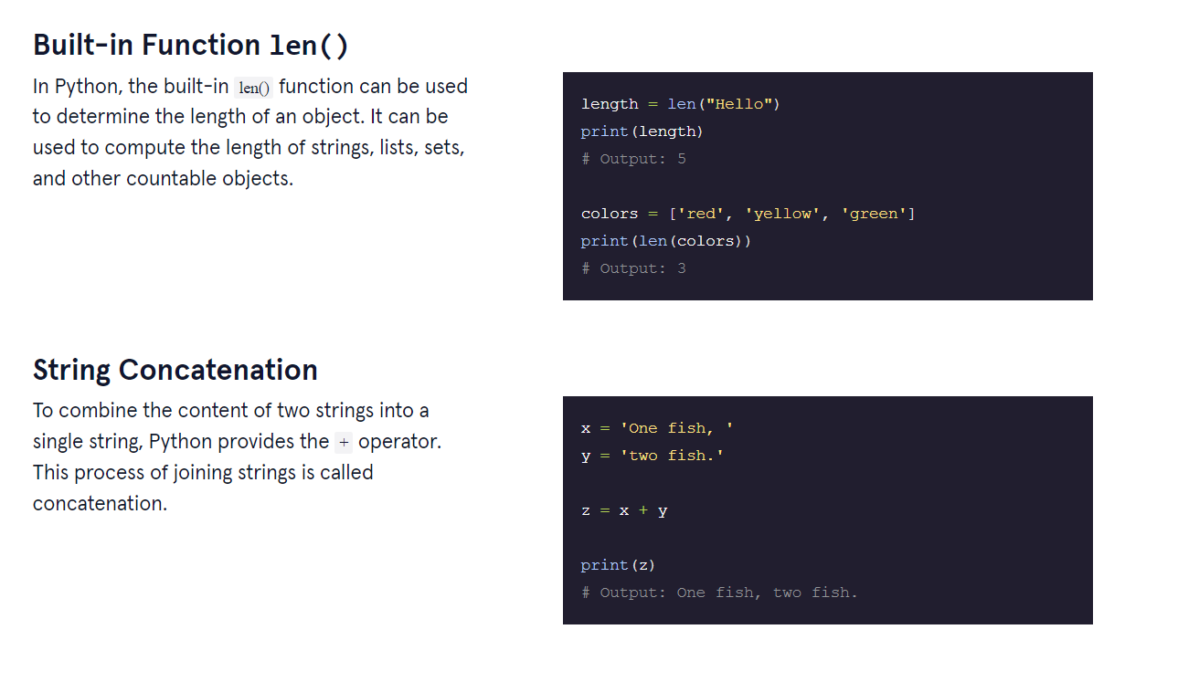

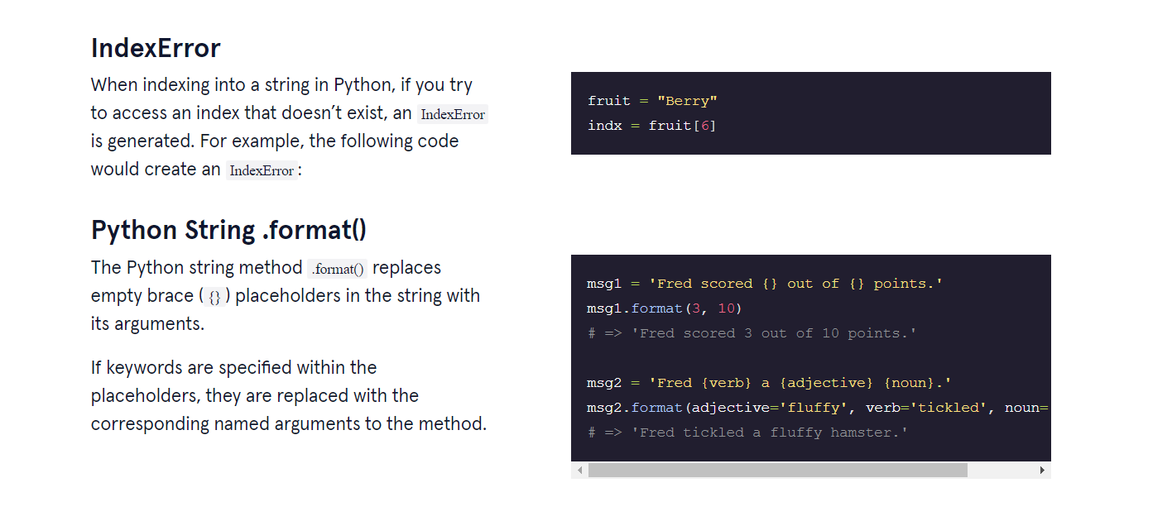

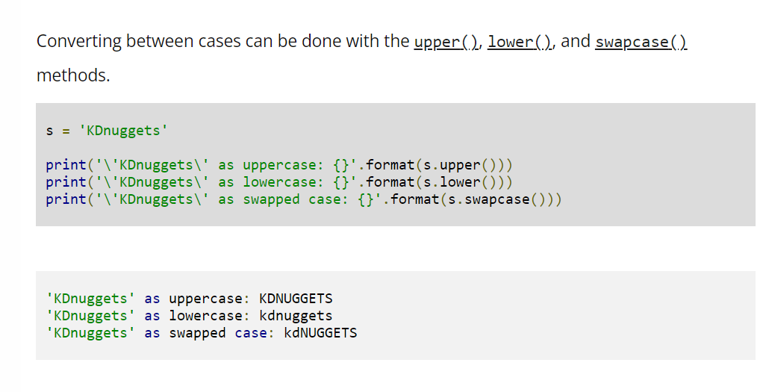

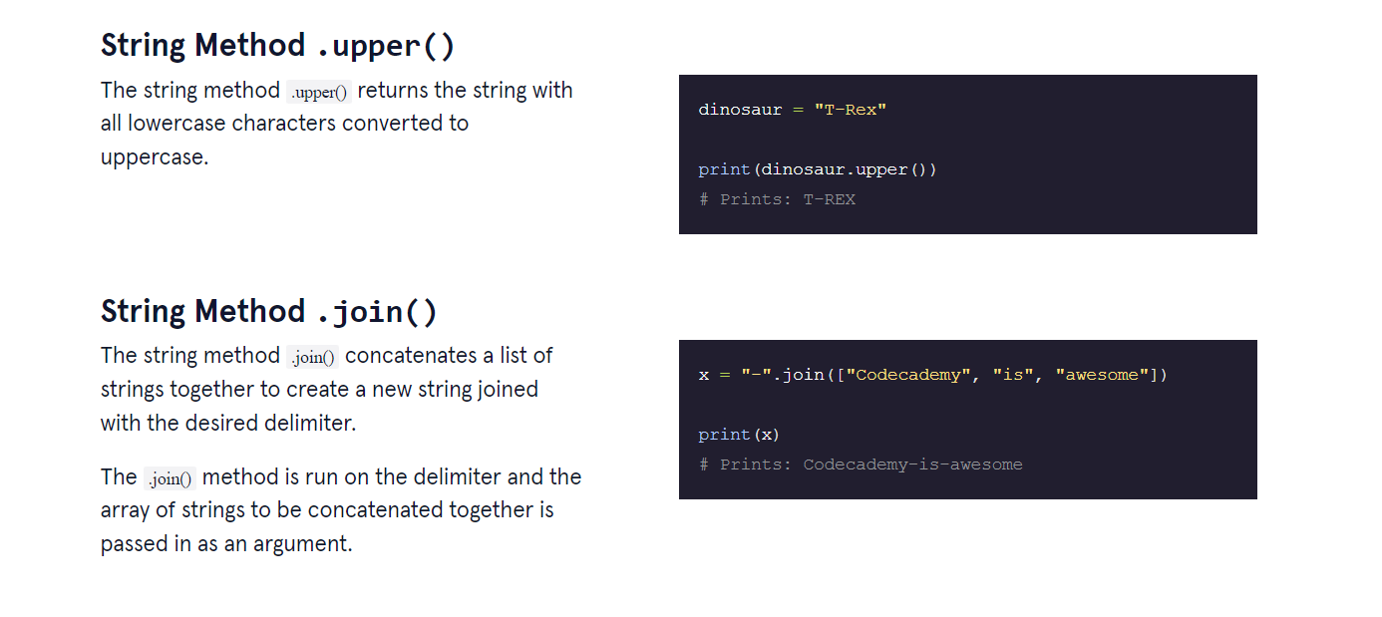

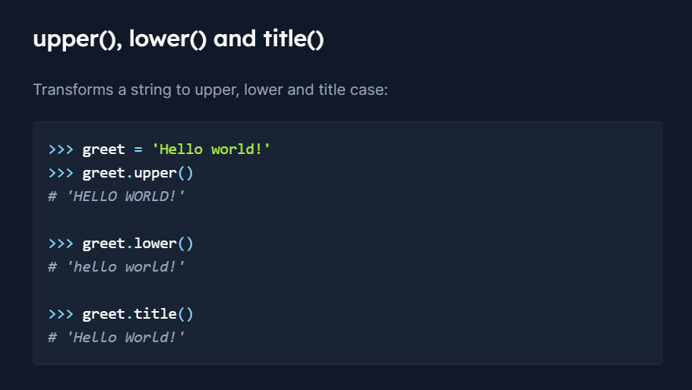

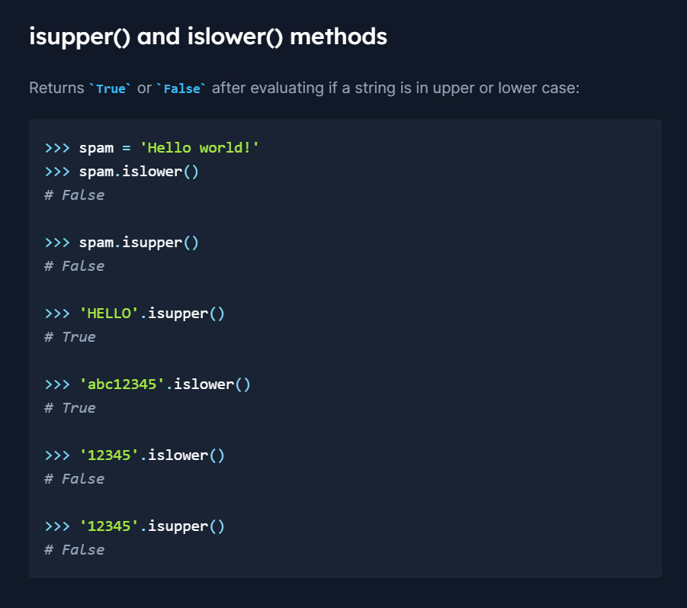

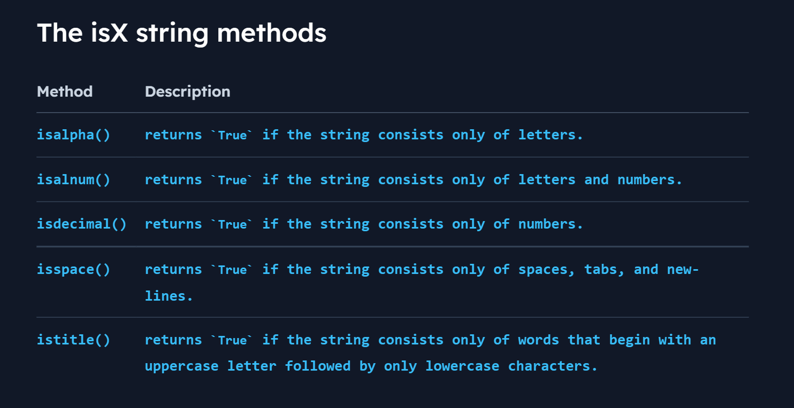

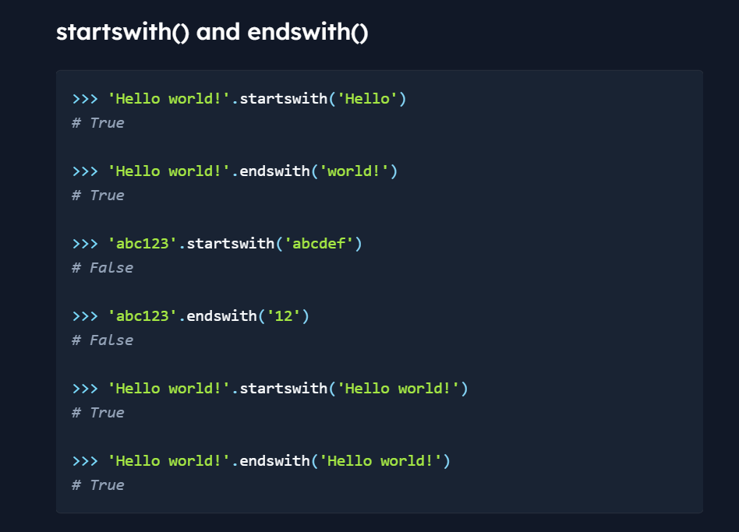

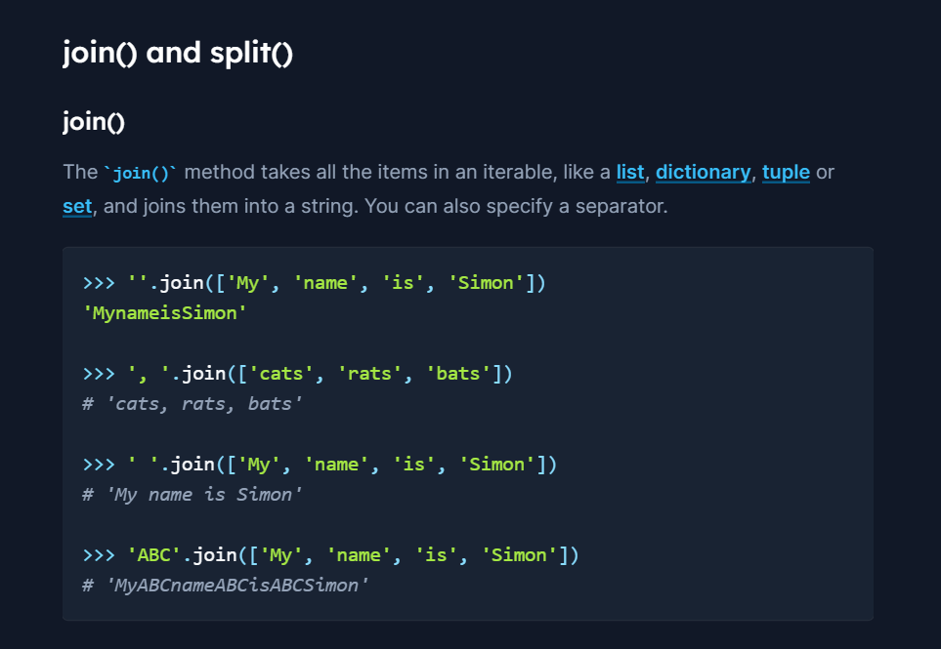

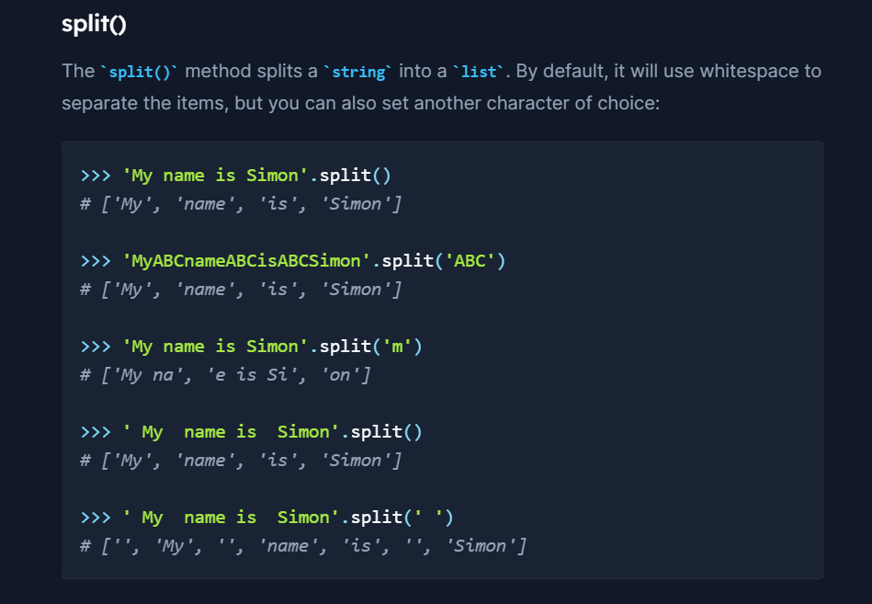

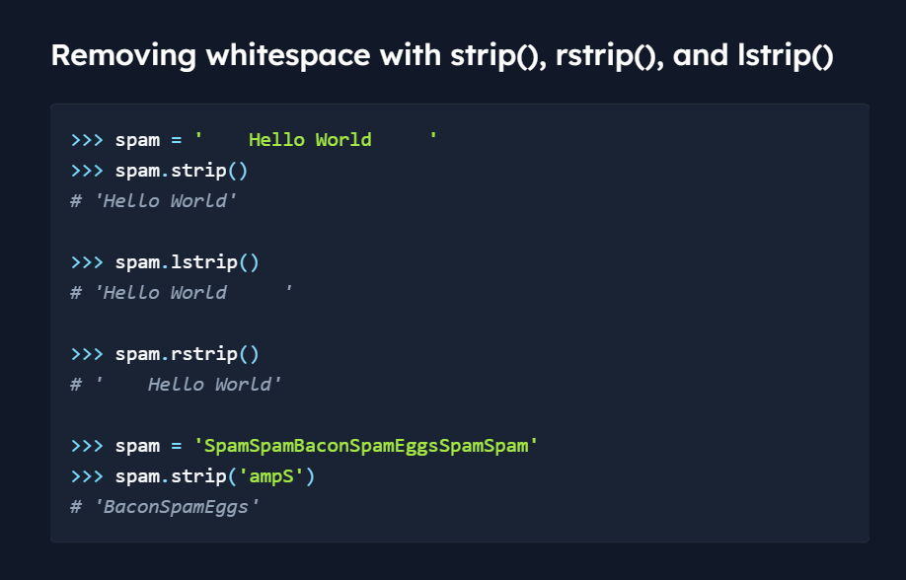

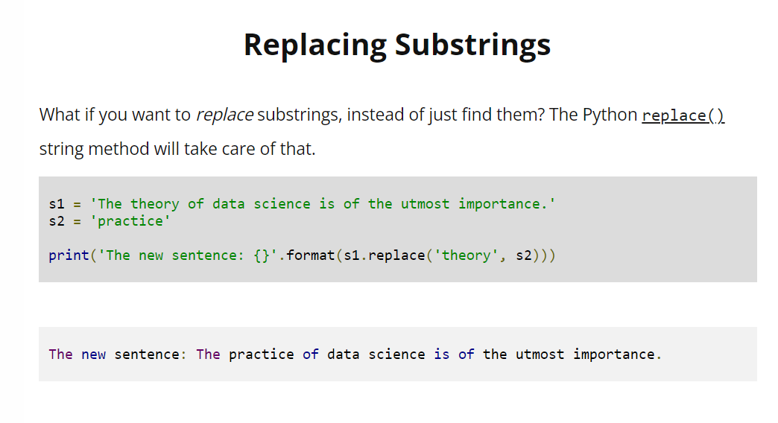

**Finding index of any character or any phrase**

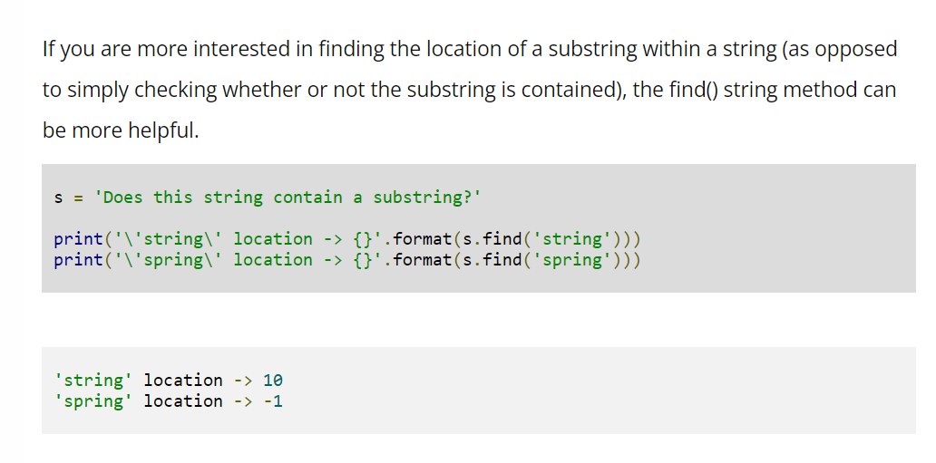

Returns -1 if the phrase or character could not be found

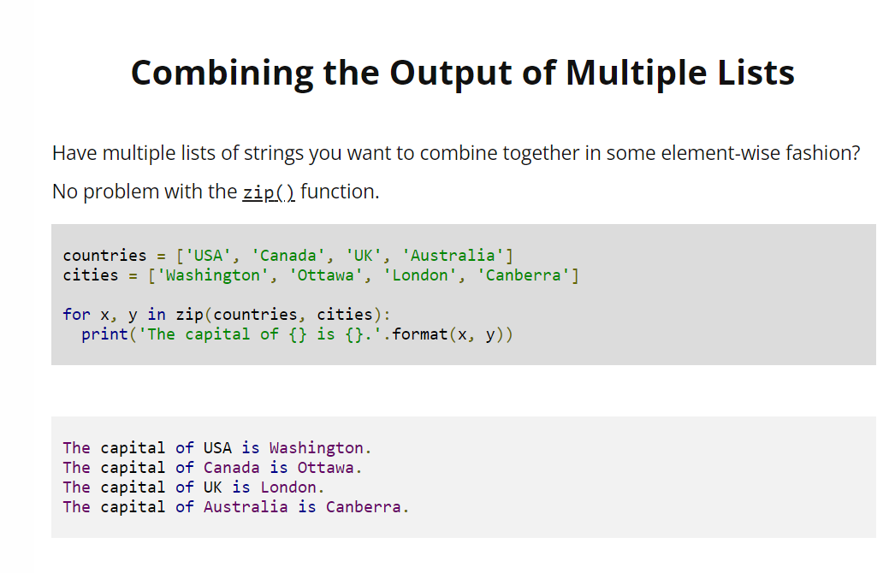

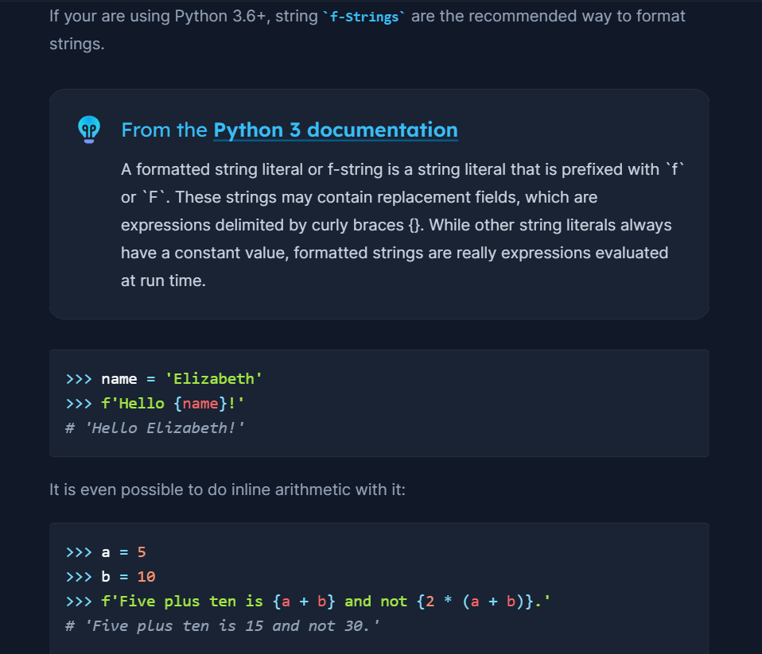

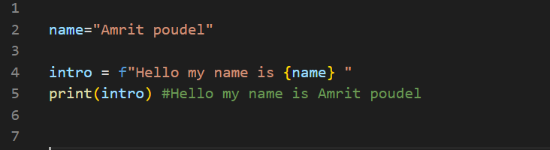

This is the latest and best way of formatting string

**Isinstance() method** is super useful

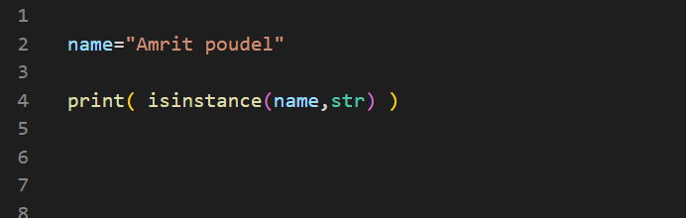

Used to check object of any class

**.join( ) and .split( ) methods**

Join( ) method is used to join the contents of any iterable object, joined with the provided separator

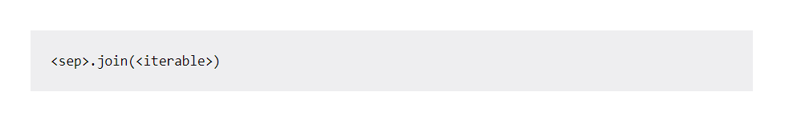

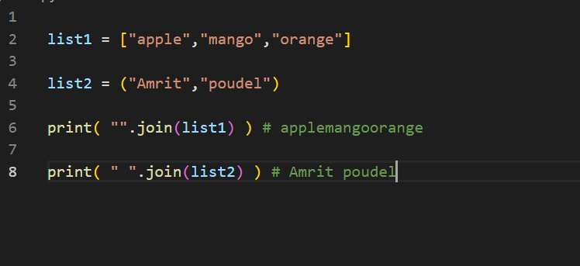

**string_variable.split(separator, maxsplit)**

this method splits the string and returns the list of separated items

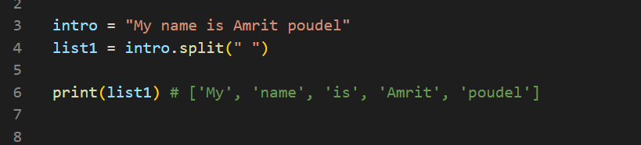

Or

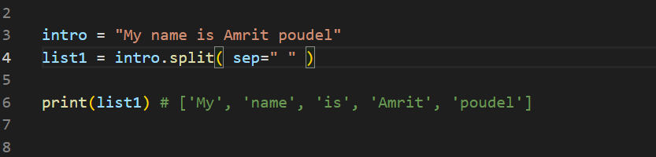

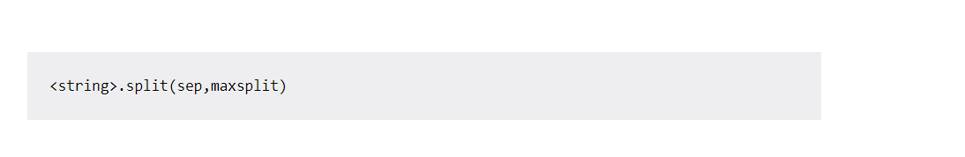

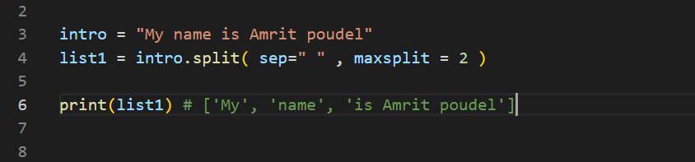

Here maxsplit = 2 means , we tell to split up to only 2 times